# 

# *‘Origin is a stepping stone to what we can do’*

Origin is a rich media ad creation and publishing suite. Custom built internally, it serves as our central hub that showcases our product line, intuitive ad creator and seamless demo creation tool.

Origin has served over 150 million ad impressions per year, generating millions in saved expenses and collected serving fees. It is highly scalable platform, compatible with the multitude of site layouts in our network.

# Overview

## Ad Template Guidelines

## Ad Creator

## Ad Preview

We approached Origin’s Ad Preview with the intention that these should properly showcase an ad unit in its proper environment.

In addition, we added support for all sites in our network. Users also have the ability to define the location where the ad unit will be rendered, as well as also define the preview page’s background skin.

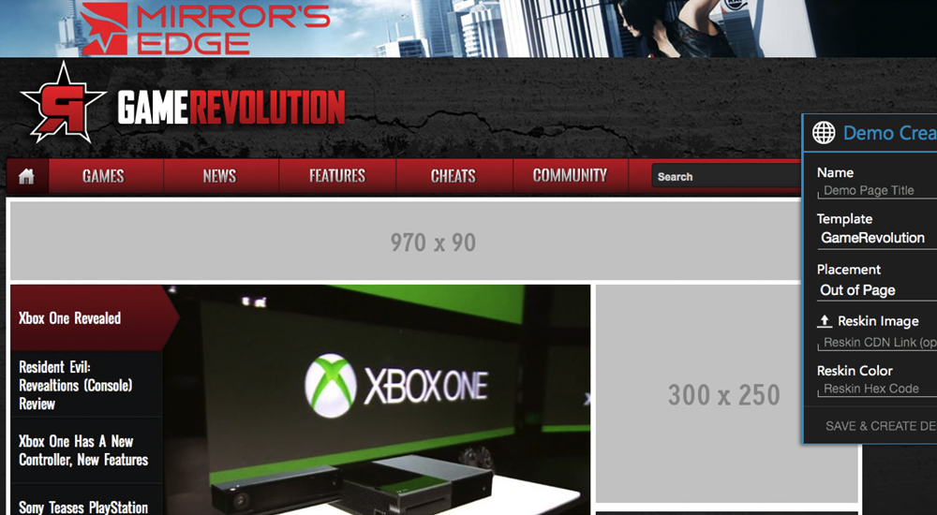

*GameRevolution – Part of the CraveOnline Media network*

*A QR code is also generated and watermarked on each page to easily display it on mobile devices.*

## Ad Serving

Origin ad units derive its templates and features from IAB ad units as well as custom in-house executions. Instead of Adobe Flash, our units are based on Web Components to deliver a rich media experience.

# Branding

## Mission & Values

* We want people to respond to the brand with interest
* Trendsetting, limitless, adaptive and innovative
* Our products are better at *everything*.



*origin (n) – something from which anything arises or is derived; source; fountainhead*

The name for the platform was derived from the theory that all ad units can share a common ancestor. The Origin brand unifies everything from the company’s name to the platform’s product line.

## Design Influences

The ‘Origin’ is also a reflection of the company name, Evolve Media, LLC., with Darwin’s *Origin of Species*. This DNA flows throughout the brand.

|  |  |
| --- | --- |
| ttp://static.guim.co.uk/sys-images/Guardian/Pix/pictures/2008/04/17/DarwinSketch.article.jpg  *Darwin’s Tree of Life* | ttp://upload.wikimedia.org/wikipedia/commons/thumb/1/12/CollapsedtreeLabels-simplified.svg/500px-CollapsedtreeLabels-simplified.svg.png  *A modern day phylogenetic tree,*  *where a species’ origins can be charted.* |

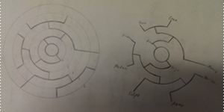

*Origin’s product ‘tree’. Contains the initial product lineup*

*and accurately associates its children and ancestors.*

For our logo icon, we needed it to be simple and abstract. The circle motif is associated with our platform so we started there. Playing upon simplifying the product tree, we noticed that it was possible to integrate in the logo type into an abstract design.

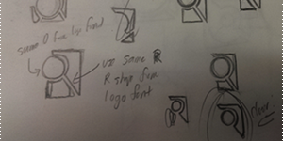

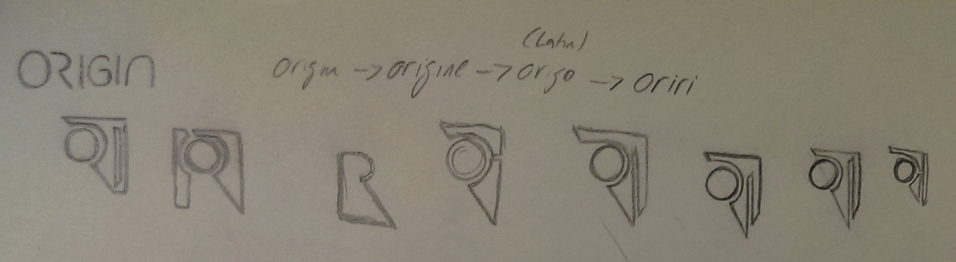

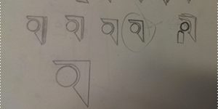

We’ve arrived at the selected design. The most prominent is the callback to the unique ‘R’ typeface from the logo type, as well as the ‘I’, integrated in to look like a shadow. It also retains a simplified version of the phylogenetic tree, with the two main branches from the point of origin.



# User Interface & User Experience

## Origin Ad Creator

Origin’s interface started out with sketches. Even though high resolution screens were the primary platform for Origin, steps were taken to also make it usable on tablets.

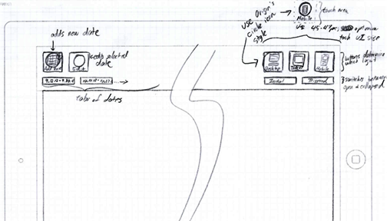

*One of the earliest layout concept for the ad creator – Trying out iconography for the UI*

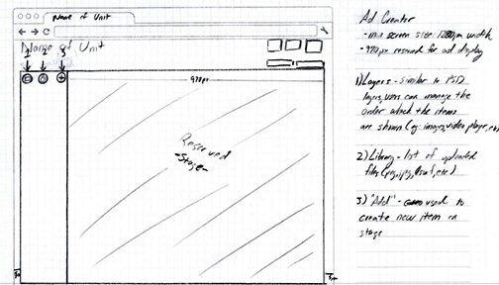

*Refinement of the first concept layout – Isolating more of the UI towards one side to optimize workflow UX*

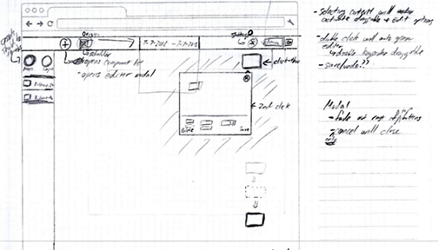

*Selected concept layout – Emphasizes a full-screen, responsive, touch-optimized placements*

*and modal windows for efficient workspace usage*

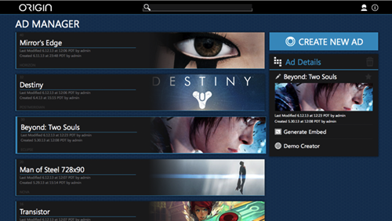

*Final Product - The ad manager layout showcases large, beautiful creatives to easily identify each project.*

*On the right, we have easy access to the ‘Generate Embed’ and ‘Demo Creator’ functions of Origin*

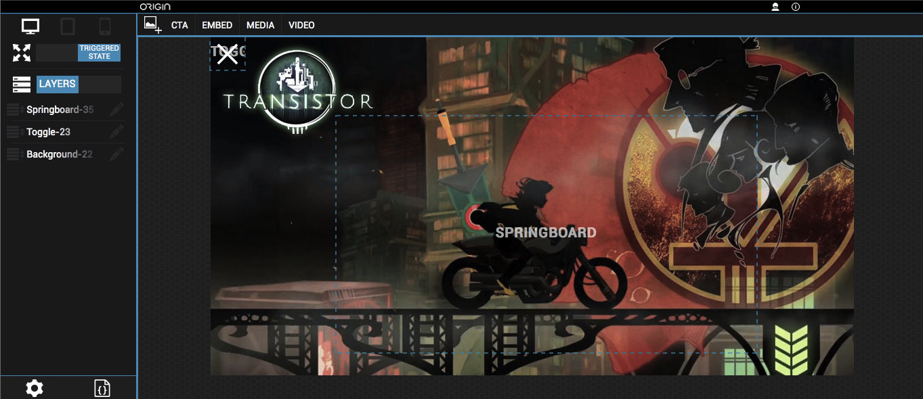

*Origin’s ad creator – While users have access to a wide breath and depth of options,*

*the interface is still very clean and simple.*

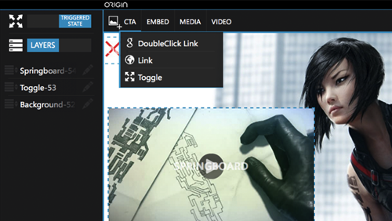

*Grouping the various components into dropdowns helps minimize interface clutter*

*and streamlines the amount of information that can be shown*

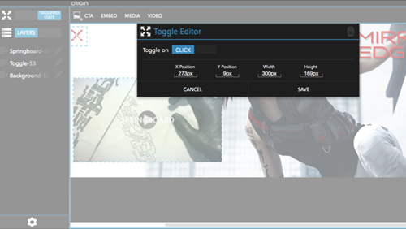

*Utilizing a modal window for the component’s editor provides the most flexibility in terms of screen estate*

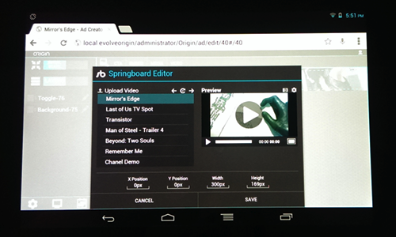

*Origin Ad Creator on a Nexus 7 tablet – Consideration was taken to*

*ensure an usable experience on touch devices and the workflow is consistent*

# Technology

## Server Side

Origin is built with the CakePHP primarily for the MVC framework. Out of the box, we’ve included an user authentication/management system and real-time CSS and JS minifier.

Beyond that base, the rest of the Origin platform was custom built, without the use of CakePHP’s ‘Bake’ function. We implemented custom routing based on our Akamai caching setup, RESTful API and custom templates.

## Client Side

Origin utilizes AngularJS as the main Javascript framework. Also included is jQuery to support various pre-made plugins. This was used as a temporary solution – we intend to translate all the jQuery plugins into AngularJS.

## Web Components

AngularJS provides the ability to create HTML5 Web Components. This was utilized throughout the Ad Creator. For example – The ‘workspace-content’ element provides dragging, resizing and editor functions built into the element.

## Modular Architecture

Origin’s Ad Creator utilizes a decentralized architecture. The components tool - adding custom elements to an ad unit – is a self-contained HTML partial.

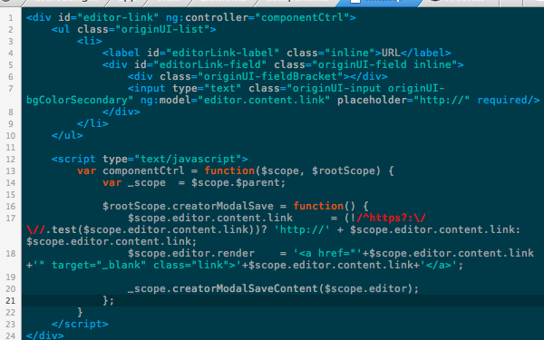

*HTML partial of Origin Ad Creator’s ‘Link’ component*

This HTML partial contains the editor featured as well as the rendered HTML element. AngularJS’s model binding allows us to efficiently update the rendered HTML in real-time from user input.

This modular workflow allows additional ‘components’ to be added to the platform as separate files, without needing to re-factor previous code.

## Ad Preview URL Shortener

Origin’s demo links utilize an encrypted and shortened URL. This permits a links to be easily sharable without exposing other demo pages with a seemingly random URL naming scheme.

The shortened URL is a hash of the demo page’s primary ID from the database. The hashing algorithm uses prime numbers approaching the golden ratio to give the impression of randomness and prevents data collision.

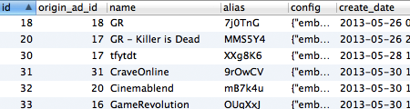

The demo page lookup overhead for the database has a time complexity of O(1), as each alias field is always unique.

## Ad Embed Code

Origin ads are deployed through the use of an universally compatible, asynchronous Javascript embed code. The ads are rendered through the use of the **origin.js** file – the embed script only loads it once, even with multiple Origin ads on the page.

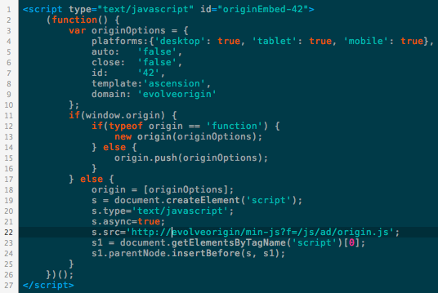

# Ad Units



Origin ad units utilize a hybrid of server side rendering plus client-side AngularJS. We’re able to achieve ‘rich media’ ad experiences without the standard industry use of Adobe Flash.

Instead of the traditional method of creating the ad units directly into the DOM, we run them through iframes. With iframes, it allows us greater freedom in frameworks to use within the ad unit without affecting the parent site.

## Ad Templates

Unlike standard industry ad unit trends that are feature based, Origin ad units are based on templates that define a unit’s placement and trigger effect. Because we decoupled an ad unit’s features from it’s template, it allows us greater flexibility and more combinations than the standard IAB units can support.

The Origin ad templates follow an astronomy naming scheme and are as follows:

**Ascension**

An IAB Billboard unit that auto attaches to the top of the page. Intended for use with sites that use a leaderboard 728x90 unit and want to run a 970px width unit without affecting the site’s layout.

**Aurora**

A rich-media reskin unit. Gives a traditionally static unit all the ad features from the Origin platform. An example would be a site’s background showing a video or a live social feed stream.

**Eclipse**

An IAB Pushdown unit.

**Horizon**

An IAB Pushdown unit that auto attaches to the top of the page.

**Meridian**

An IAB Interstitial unit. Includes both a prestitial (auto activates upon page load) and an interstitial (activates only upon clicking on internal site link)

**Nova**

Overlay ad unit. Comes in two parts – one in-page unit and a triggered out-of-page unit.

**Singularity**

IAB Billboard unit.

Adaptive and Fluid Ad Templates

Each Origin ad unit has the option of displaying a unique creative targeted to Desktop, Tablet or Mobile platforms. The creative delivered are catered to each individual platform, optimizing the load bandwidth required.

When creating a new Origin ad creative, a copy of the Origin ad template is made for this instance. This allows users to individually set the dimension and animation values of the ad unit independently of template defaults.

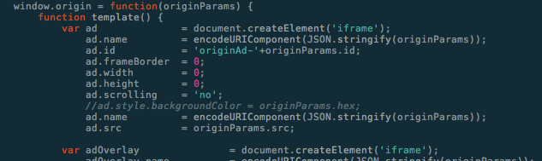

*An Origin unit initially starts off as just a dimension-less iframe container*

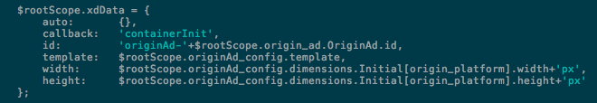

*When the iframe loads, it executes a callback - providing the ad’s current dimension properties*

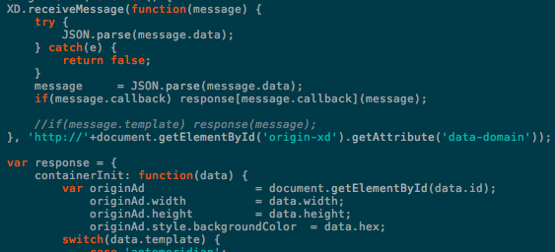

*The Origin script on the publisher site receives the properties*

*and updates the ad iframe container – revealing the unit on the site*

## Cross-Domain Iframes

The key technology with our ad units is the ability to perform cross-domain communications. HTML5 provides a PostMessage specification which permits us to bypass the same-domain security restrictions from earlier browsers.

The trigger effect (expansions or overlays) is achieved through synchronizing both expansion animation of the ad unit and the containing iframe on the publisher site.

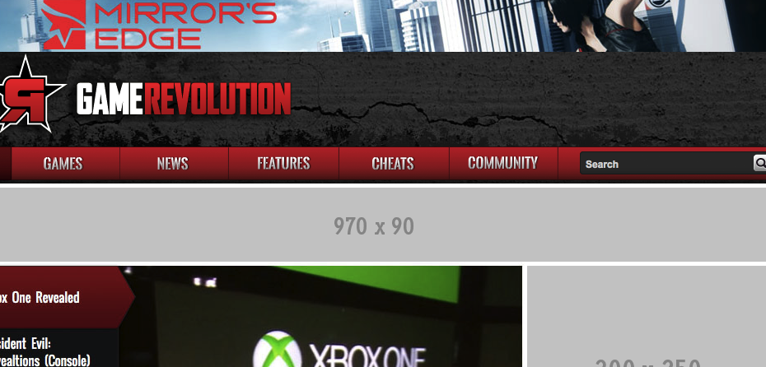

*An Origin ad unit on a publisher site.*

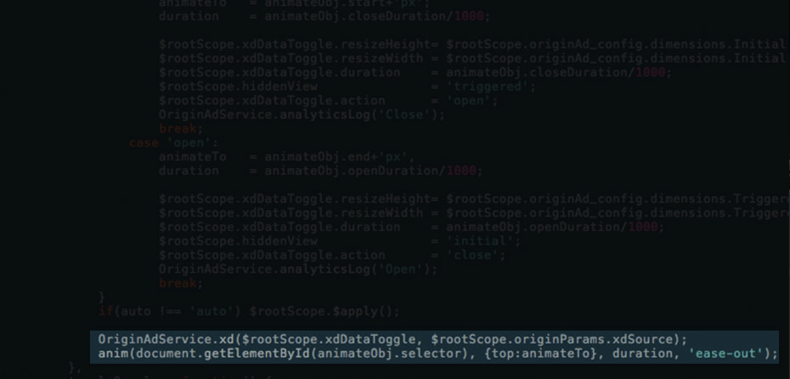

*Triggering the CTA will run the expansion animation and perform a PostMessage call*

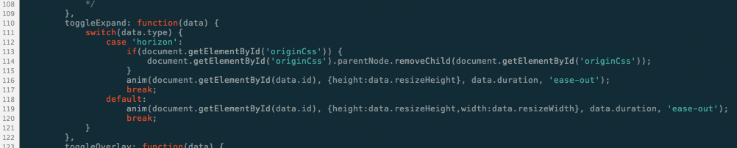

*The PostMessage is authenticated by origin-xd.js on the publisher site*

**

*The origin-xd.js code then animates open the ad containing iframe – providing a seamless experience*